Introduction to Virtual Reality

BY: PRIYANSHU KAMBLE

BE(AI&DS)

**Introduction:**

Imagination is to Technology as Fuel is to Fire. Imagination and purpose together drive technology. It is due to these that technology today is evolving at an exponential rate. Virtual Reality on the one hand places the viewer inside a moment or a place, made possible by visual and sound technology that maneuvers the brain into believing it is somewhere else. It is an experience of a world that does not exist. Sounds cool, right?! Virtual Reality tricks one’s mind using computers that allow one to experience and more interestingly, interact with a 3D world. This is made possible by putting on a head-mounted display that sends a form of input tracking. The display is split between the eyes and thus creates a stereoscopic 3D effect with stereo sound to give you a graphic experience.

The technology feeds on the images of the objects taken at slightly different angles which creates an impression of depth and solidity. The LCD or OLED panels inside are refracted by lenses completely fill the field of vision with what is to be displayed and experienced. Together with technology and input tracking, it creates an immersive and exciting believable world that the computer generates. What we know today as VR has existed for decades now. Taking you back to when 360° paintings took the world by surprise, giving a virtual element. VR merely is ‘The Wise Guy’ of the digital world. It creates a world that neither functions according to you, nor does it respond to your actions. It gives you a first-hand experience with even the after-effects of an event along with the ability to interact and interrelate with the world created. This technology holds vast potential insights into the workings of the Human Brain. According to researchers and medical specialists, VRs could diagnose medical conditions from social anxiety to chronic pain. Though the use of VR to tweak the brain is still at a budding stage. While most people were too engrossed in its advancements and leap in gaming and exploring the industry, many are unaware of its achievements in the health sector. VRs have been successfully treating post-traumatic stress disorder since the 1990s, the new programs thus address a much broader range of conditions.

VR content exposes the patients to a virtual, safe, and controlled environment where they can explore and eventually learn that the threats, they are worried about can be tackled patiently with time, thinking, and analyzing. VR displays are available in various forms. Ranging from the ones that already contain the display, splitting the feed for each eye using a cable to transfer the feed to the console, to the more affordable ones which depend upon the VR mode and applications on Smartphones. The HTC Vive, the Oculus Rift, and Sony PlayStation VR are a few of the head mounts that use this setup. One can create one’s own Virtual Reality Box at home, along with a

**Types of Virtual Reality (VR):**

Based on the most important feature of VR i.e., immersion and the types of systems and interfaces used, The VR systems can be classified into 3 types:

Immersive  
Semi-immersive  
Non – immersive

1. Immersive VR system

Immersive VR system is closest to the virtual environment. It makes us experience the highest level of immersion. This VR system is more expensive than others. It provides the closest feeling of being in virtual world. Tools and gadgets used in this system are advanced and not so common to use. Immersive virtual reality is a technology that aims to completely immerse the user inside the computer-generated world, giving the impression to the user that they have "stepped inside" the synthetic world. This is achieved by either using the technologies of Head-Mounted Display (HMD) or multiple projections.

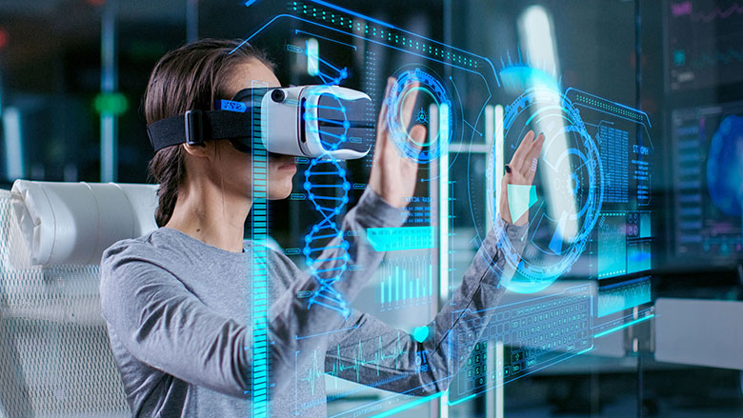

2. Semi– immersive VR system

Semi – immersive VR systems also allow us to experience a high level of immersion, but the tools and gadgets used are not so advanced and costly. Tools and gadgets used in this system are common to us and utilize physical models.

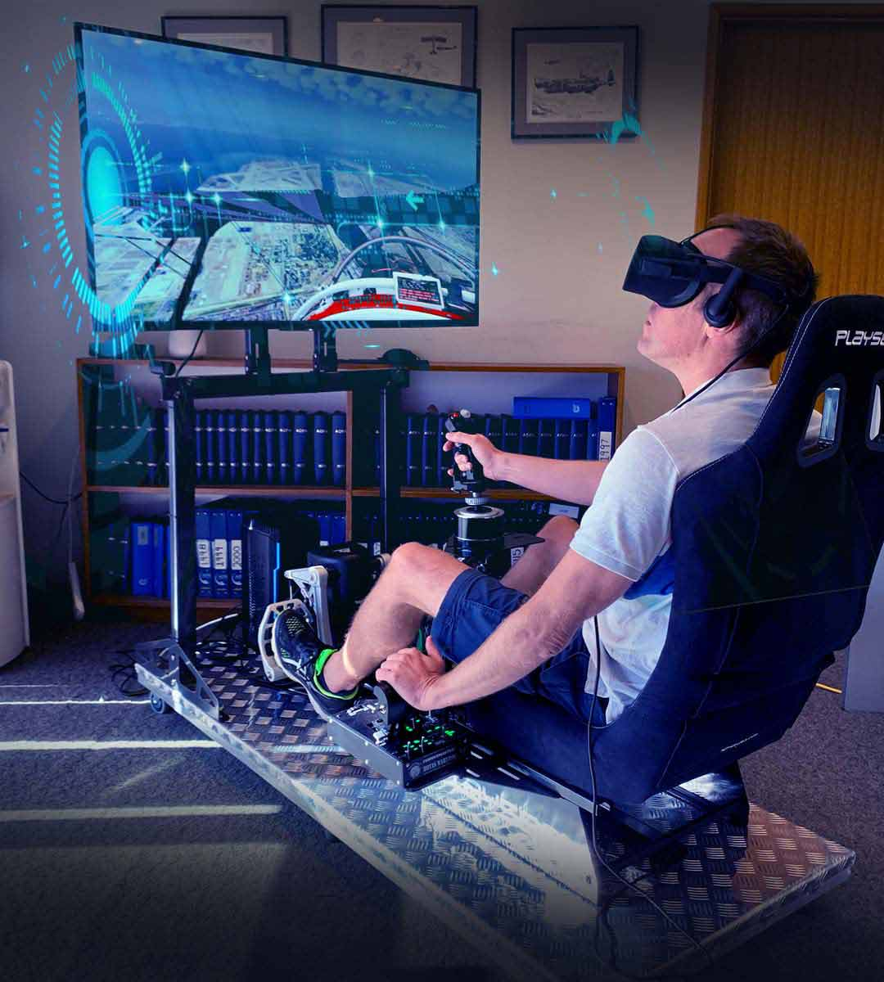

3.Non-immersive VR system

Non-immersive VR system is the least immersive and least immersive VR system. It is not expensive to use this system. It is also known as desktop VR system because the gadgets used are limited to glasses and display monitors and it uses the least expensive components.

**Basic components for VR systems:**

Input devices  
Output devices  
Software

1. Input Devices

Input devices in VR are the tools for the users to interact with the virtual world. Using Input devices, the users communicate with the computer.

Example – 3D mouse.

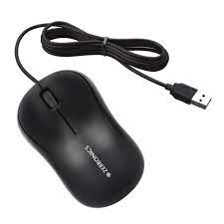

2. Output devices

Output devices are used to represent the virtual world and its effect on the users. It generates the feeling of immersion to the users.

Example: LCD shutter glasses

